Taking Scientists to School:

Using Nevada’s Climate Research for K-12 Science Curriculum

This series of lessons focuses on some of the exciting climate change research that is the result of the multidisciplinary research conducted through the Experimental Program to Stimulate Competitive Research (EPSCoR) program created by the National Science Foundation (NSF).

There are so many people working to understand climate change in Nevada: how we affect it and how it affects us. Within these lessons, students get to learn about research taking place now in Nevada and, more importantly, will be able to use the research they learn about to spark their own interest and understanding in areas related to climate change.

Each lesson is designed so that students can explore information related to climate change and form their own ideas about research questions they are presented with. They will then use the EPSCoR researcher’s expertise to evaluate their explanations before sharing their ideas with their classmates.

For this lesson, students will explore what it means for an information source to be usable and how that affects our trust in an information source:

**HOW DOES THE USABILITY OF AN INFORMATION SOURCE AFFECT HOW WE USE IT?**

**Time to complete:** 3 to 5 class periods

**Grade level:** 9th-12th grade

**Standards:**

**NGSS**:

*Science and Engineering Practices*:

* Asking questions
* Constructing explanations
* Engaging in argument from evidence
* Obtaining, evaluating, and communicating information

### *Disciplinary Core Ideas*:

### HS-ESS3-4: Evaluate or refine a technological solution that reduces impacts of human activities on natural systems.

### *Crosscutting Concepts*:

* Patterns
* Stability and Change

**INTRODUCTION**

When we think about climate change, there is A LOT of information available on the internet. Not only is there a lot of information, but it comes in many forms. Sometimes it is very hard to process because it is technical and specialized information that might be easy for researchers to digest, because…well, they created it. In order for the public to understand climate change information on the Internet, websites are designed to maximize *usability.*



Ivan Gibbs and the research team he works with at the University of Nevada in Reno are trying to help both scientists and laypeople access and understand information related to climate change. He and others are researching and developing the best ways to represent information to ensure that it is understood and relied upon.

For this lesson, you will be exploring the same ideas and evaluating web-based information sources to understand usability of an information source affects how we use it to get information.

**How This Lesson Works**

This lesson is focused on a **Big Question.** The activities are divided into different sections or features.

1. With feature one of the lesson, you will be asked to respond with your initial ideas related to the Big Question. In every additional feature of the lesson, you have the opportunity to provide any further thoughts or questions that arise.
2. Feature two of the lesson is an activity where you are required to collect and explore some evidence related to the science content of the Big Question. This evidence is used throughout the remaining features of the lesson.
3. Feature three of the lesson involves analyzing your evidence and using it to generate an explanation (also called a claim) about the scientific ideas of the lesson. Typically, your analysis will produce an artifact that you will describe and justify to your peers and teacher at Research Council.
4. The accepted scientific understanding of the lesson is presented in feature four. In addition to demonstrating a thorough understanding of the scientific knowledge of the content, you will be asked to compare and contrast your explanation from feature two.
5. Finally, feature five of the lesson involves sharing and justifying your explanation and artifact from feature three among your peers and with your teacher at Research Council. The culminating activity of the lesson is to reflect on the Big Question of feature one and synthesize your understanding by using your evidence to compare and contrast your ideas with those of your peers and teacher.

**The Big Question**

In this lesson you will explore the **Big Question** below and work through five different steps to address it. At certain points, you will be asked to complete a few activities like: reading, responding to some thoughtful questions, and adding to your research brief. You should take your time and think carefully about each step and your work and feel free to revisit any step at any time. We will review the concepts in class.

**The Big Question:**

HOW DOES THE USABILITY OF AN INFORMATION SOURCE AFFECT HOW WE USE IT?

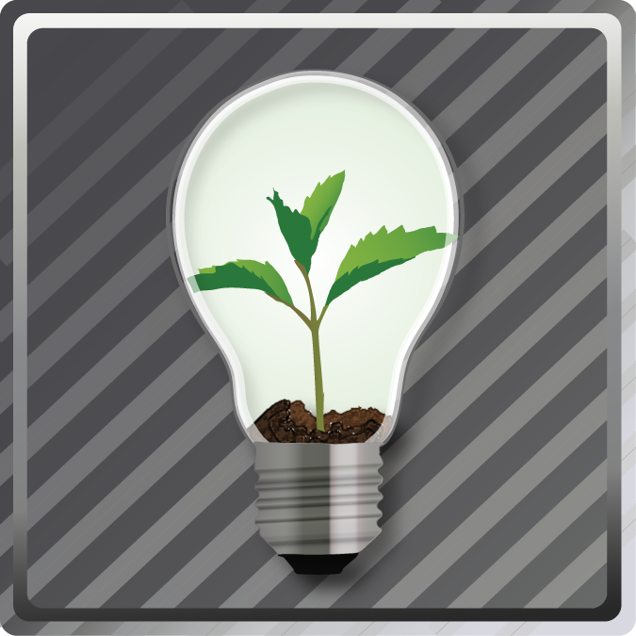

**FEATURE 1: YOUR INITIAL IDEAS**

**Task 1: Exploring information to answer a question**

Think about the following question:

*How is climate change going to affect Nevada?*

Before you move on, discuss your thoughts with your group/partner. Go!

Did your group come up with some good ideas? Do you know if your ideas were correct? You were probably left with more questions instead of solid answers, right?

When we don’t know the answer to complicated questions like this, we often go to the internet to for information. We can use Google, Yahoo, or some other search engine that will direct us to the information sources we need to answer the question.

The links below will direct you to information sources that resulted from typing, “*How is climate change going to affect Nevada?”* into the Google search bar. Explore the information presented by clicking on each link. You don’t have to read everything, but read enough consider how easy it is to answer the question from the information each link presents. Talk to your partner about your ideas.

[Wikipedia: Climate Change in Nevada](http://en.wikipedia.org/wiki/Climate_change_in_Nevada):

http://en.wikipedia.org/wiki/Climate_change_in_Nevada

[Environmental Protection Agency: Nevada Climate Change Advisory Committee Final Report](http://www.epa.gov/statelocalclimate/documents/pdf/nevada_final_report.pdf):

http://www.epa.gov/statelocalclimate/documents/pdf/nevada_final_report.pdf

[Nevada Climate Change Portal](http://sensor.nevada.edu/NCCP/Default.aspx):

http://sensor.nevada.edu/NCCP/Default.aspx

**Task 2: What do you think usability is?**

Now that you have explored the usability of a few information sources, talk to your group/partner about what you think usability means. Then, take time to answer the questions below in you Research Brief.



Research Brief: Getting Started

Use the following prompts to discuss some of your initial ideas about an information source’s usability and how it impacts what we know about something. Use the prompts to spark your thinking.

1. After looking at the information sources presented here, what do you think usability means?

I think usability is…

1. Which information source did you think was the most usable? Why?

I thought that ____________________ was the most usable, because…

1. Which information source would you rely upon to learn about the impacts of climate change in Nevada? Why?

I would use______________, because…



**FEATURE 2: EXPLORE THE EVIDENCE**

**Task 1: Taking a closer look**

Now take a look at the same websites you looked at in Feature 1. Think more specifically about what makes the website usable or not. Use the questions below to prompt your thinking. Discuss each of the questions with your partner, but you don’t have to respond to them in your Research Brief just yet.

*Questions to consider:*

1. How well are you able to get the information you need to answer the question from the website?

2. What makes obtaining the information easy or difficult?

3. Is that information presented in a way that you can understand?

4. Who do you this is the audience for the websites that you visit?

5. Which website would you trust to get you information and why?

1. [Wikipedia: Climate Change in Nevada](http://en.wikipedia.org/wiki/Climate_change_in_Nevada):

http://en.wikipedia.org/wiki/Climate_change_in_Nevada

2. [Environmental Protection Agency: Nevada Climate Change Advisory Committee Final Report](http://www.epa.gov/statelocalclimate/documents/pdf/nevada_final_report.pdf):

http://www.epa.gov/statelocalclimate/documents/pdf/nevada_final_report.pdf

3. [Nevada Climate Change Portal](http://sensor.nevada.edu/NCCP/Default.aspx):

http://sensor.nevada.edu/NCCP/Default.aspx

**Task 2: Assess the websites using expert criteria**

Now that you have explored some of your own ideas about usability, let’s take a look at some of the criteria that experts use to assess information source **usability**. The links below will direct you to 2 websites. The first gives you an expert’s explanation of **usability**.

The second directs you to an article describing ten rules of thumb, created by Jakob Nielsen, to evaluate website usability with examples demonstrating what they mean. Though the wording is technical, you have probably already used some of these rules of thumb as you have evaluated the websites in the previous section. Read through each of the criteria and, in your Research Brief, write down which ones you considered when you were assessing the websites in the previous section. Did you already have some good ideas about what makes a website usable?

[Web Usability:](http://www.nngroup.com/topic/web-usability/) http://www.nngroup.com/topic/web-usability/

[Designing Web Interfaces:](http://designingwebinterfaces.com/6-tips-for-a-great-flex-ux-part-5) http://designingwebinterfaces.com/6-tips-for-a-great-flex-ux-part-5

Now use the checklist below to assess the usability of the same three websites from the beginning of the activity. The checklist is derived from the expert ideas you just read. Answer each question with a number 1 to 5, based on how well the information source/website demonstrates the rule of thumb. You can also fill in the box with NA, for “Not Applicable” if it is something you did not have experience with.

**1=not well at all 2=not very well 3=neutral 4= pretty well 5=extremely well**

|  |  |  |  |
| --- | --- | --- | --- |
| **Rules of thumb** | **Website 1: Wikipedia** | **Website 2: EPA** | **Website 3: Nevada EPSCoR** |
| How well does the website let you know what is going on the interface? For example, if a document is loading, is there a graphic or wording that lets you know? |  |  |  |
| How well does the information source use wording you can understand? |  |  |  |
| If you navigate to a page you didn’t want to, is there an easy way for you to get out of that page? |  |  |  |
| Does the website use navigation language you are already familiar with? For example, many websites use words like, “Back,” “Homepage,” or “Continue” to help you navigate. Is this information source consistent with that language? |  |  |  |
| Does the website prevent you from making errors? |  |  |  |
| Do you have to use your memory to navigate to the pages you want to see? |  |  |  |
| Can you use this website if you are not very good at using the internet? If you are an expert internet user, will it seem to simple, with not enough options? |  |  |  |
| Is there enough wording to give you plenty of information, without there being too much, so that you can’t get through it all? |  |  |  |
| If you receive an error message, is it clear and does it suggest a way to fix the problem? |  |  |  |
| Is there a clear way to get help using the website or information source? |  |  |  |



Research Brief

Use the following prompts to discuss your ideas about usability and how they may have changed after thinking more specifically about what it means.

1. After looking at the information sources presented here, and considering the questions above, what do you think usability means?

I think usability is…

1. How have your ideas changed since Feature 1?

My understanding of usability has change in that…

1. What are the most important features that an information source should have to be usable?

The most important parts of usability are…

1. Which information source would you rely upon to learn about the impacts of climate change in Nevada? Why?

I would use______________, because...



**FEATURE 3: YOUR SCIENTIFIC CLAIMS**

You have examined and evaluated data on both climate change and its impacts in Nevada. You now must develop claim-evidence-reason statement describing your understanding of website usability and how we obtain information from various sources. The evidence you cite should come from your evaluation of websites using expert criteria. Use the Evidence-Claim-Reason table below to develop your claims. An example is provided.

|  |  |  |  |
| --- | --- | --- | --- |
|  | **As evidenced by…** | **I claim…** | **Because…** |
| 1. |  |  |  |
| 2. |  |  |  |
| 3. |  |  |  |
| 4. |  |  |  |

Use your completed ECR Table to create a claim statement for each action item you propose.

Example:



Research Brief:

Complete the following starter prompts in your Research Brief:

Claim Statement Starter Prompts:

1. As evidenced by... I claim that ... because...
2. As evidenced by... I claim that ... because...
3. As evidenced by... I claim that ... because...

**FEATURE 4: SCIENTIFIC UNDERSTANDING**

Use the link to the website below to better understand some of the principles of usability. Each of the principles described has been researched by experts in the filed. Some are very specific and some are more general. How do these ideas compare to the ones you have developed in Features 1-3?

[10 Useful Usability Findings and Guidelines:](http://uxdesign.smashingmagazine.com/2009/09/24/10-useful-usability-findings-and-guidelines/) http://uxdesign.smashingmagazine.com/2009/09/24/10-useful-usability-findings-and-guidelines/

**FEATURE 5: RESEARCH COUNCIL**

In this investigation, you explored ideas related to website usability and how that might impact where we get our information. Your preparation required you to review sources of information on how other people design information sources and evaluate information sources using this information.

Present your Research Brief at a Research Council comprised of your classmates. Explain and defend your findings. Critique the claims presented by other students and ask them to defend their understanding of website usability and how it might impact where we get our information on climate change.

Compare your ideas with others, critically evaluate your understanding of the connection between data and visualizations, then make any changes or update your research brief as you feel is appropriate. Record the specific evidence and reasoning that caused you to want to make any changes.



Research Brief:

After Research Council, complete your Research Brief by finishing the following statements:

My ideas are similar to others because . . .

My ideas are different because . . .

Note: Use your experience in this lesson and the evidence you collected to support your claims.